1. Configure VPC peering in cross regions.
2. Purchase one domain from godaddy.

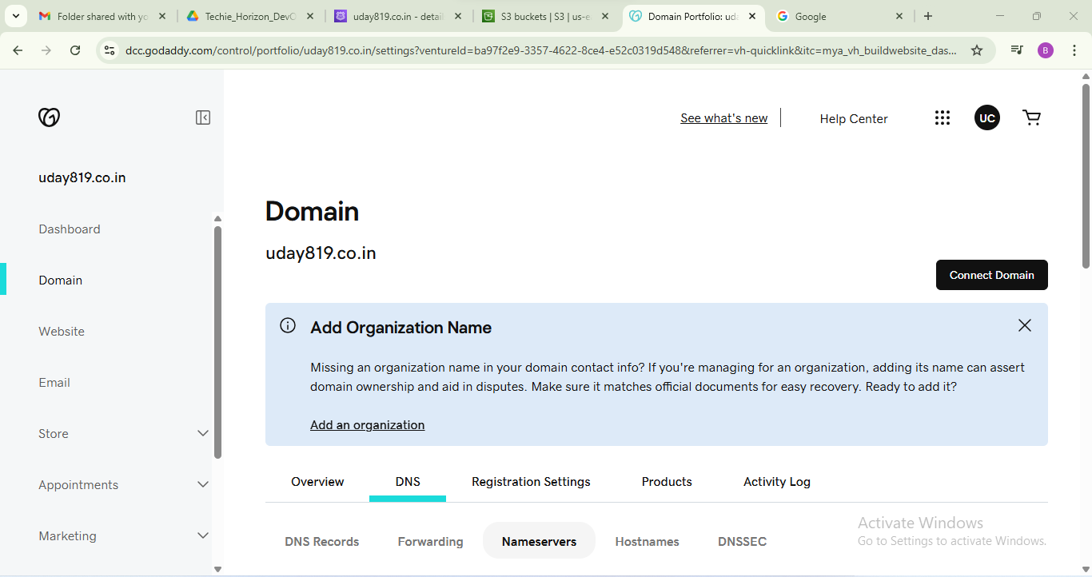

1. Deploy static webiste in s3.

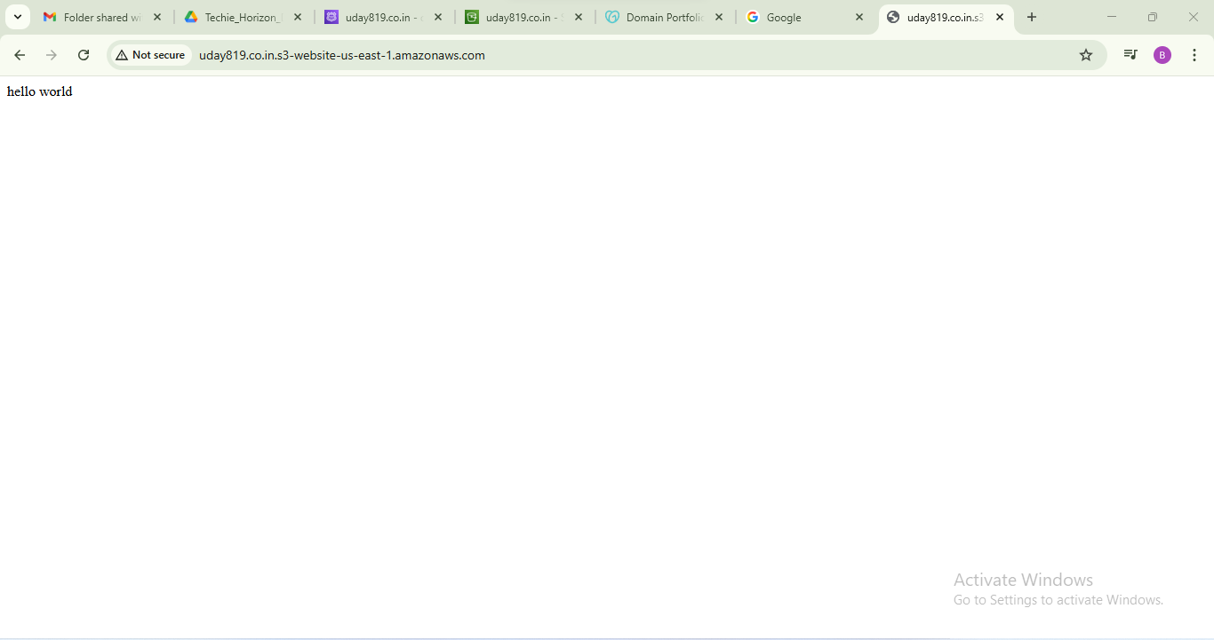

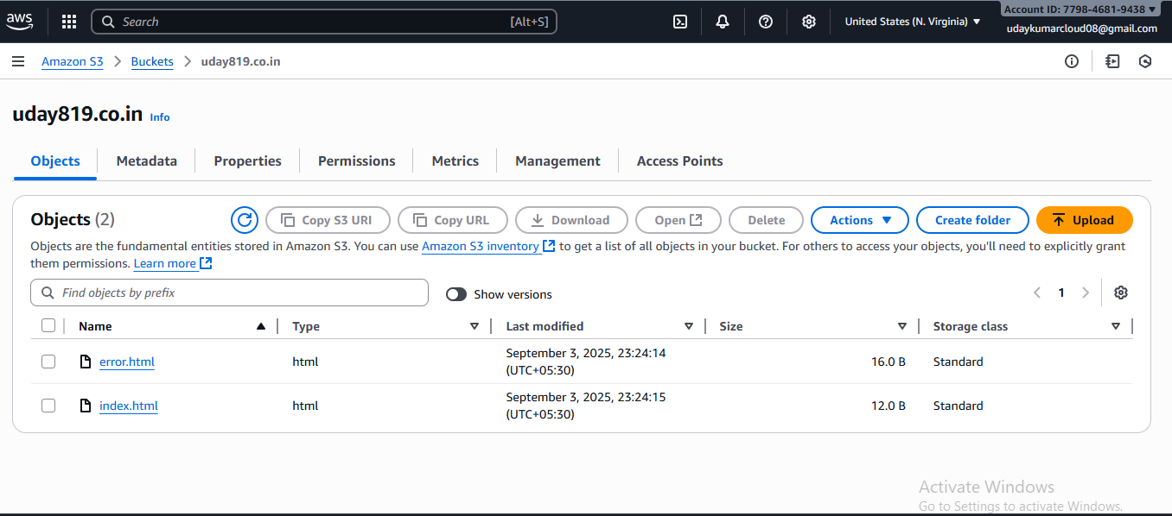

1. Create CDN and attach one SSL certificate.

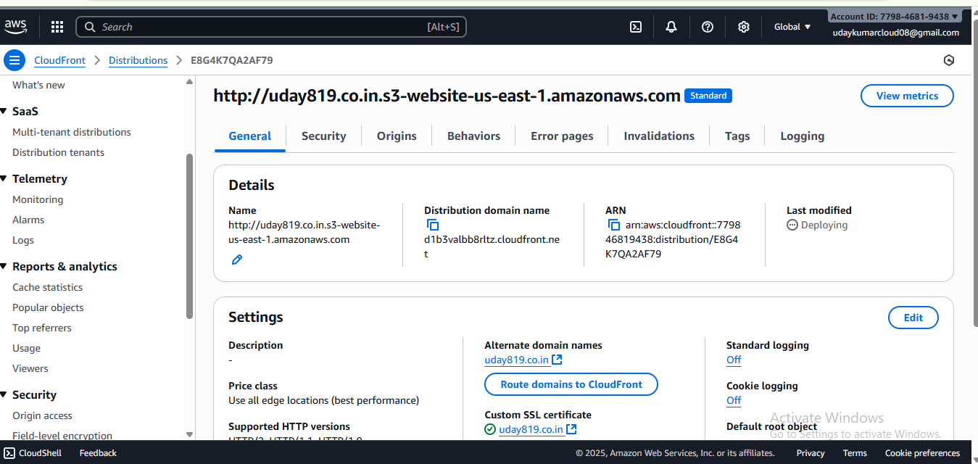

1. Create Route53 hosted zone and MAP the domain with CDN.